**MID TERM PROJECT REPORT**

**ON**

**SQL AND FRONT END**

**BY**

ANKIT KUMAR SINGH

20STUCHH010019

DS&AI



**Department of Computer Science Engineering**

**ICFAI Foundation for Higher Education**

(Deemed to be University under Section 3 of UGC Act. 1956)

**HYDERABAD**

**June 2022**

**Prepared in partial fulfillment of the**

**Internship Program – I Course**

**AT**

**JALA TECHNOLOGIES**

**INTERNSHIP PROGRAM – I**

**Department of DS & AI**

**ICFAI TECH (Deemed to be University)**

**HYDERABAD**

**JUNE, 2022**

**INTERNSHIP PROGRAM – I**

**DURATION : 31st May to 30th July,2021**

**ADDRESS : HYDERABAD**

**NAME : JALA TECHNOLOGIES**

**WORKING HOURS : DAILY UPTO 8HOURS**

**WEBSITE : https://java.jalaacademy.com/**

**COORDINATOR’S NAME : MR. HARSHA VARDHAN**

**TELEPHONE NO : +918897552023**

**EMAIL :** [**technologiesjala@gmail.com**](mailto:technologiesjala@gmail.com)

**IP-FACULTY NAME : MRS. LOREINA PAGAG**

**EMAIL : loreina.pagag@ifheindia.org**

**DECLARATION**

**I hereby declare that the work which is being presented in the mid Project report entitled JALA TECHNOLOGIES in partial fulfillment of the requirements for the Internship Program-1 of the Bachelor of Technology in Data Science and Artificial Intelligence and submitted to the Department of Data Science and Artificial Intelligence of The ICFAI Foundation for Higher Education is an authentic record of my own work carried out during internship.**

**The matter presented in this report as not be ensubmitted by me for any other course or for any other degree elsewhere.**

**Signature of the student**

**ANKIT KUMAR SINGH**

**This is to certify that the above statement made by the candidate is correct to the best of my knowledge.**

**Date: 30-06-2022 Signature of the faculty**

**Place: Hyderabad**

**ACKNOWLEDGEMENT**

I would like to thank all those who have directly or indirectly contributed to the completion of the “JAVA, SQL and Frontend” project reports. First of all, I am very grateful to the ICFAI (Faculty of Science and Engineering) of my university and all their cooperation and contributions for providing me with this opportunity to get a vast knowledge about how things work in industry and on what basis does the work is assigned and managed by people. Also, I would like to thank our mentor Dr. Loreina Pagag mam.

**ABSTRACT**

I’m pursuing a four-year degree in Engineering with a focus on Artificial intelligence & Data science and Engineering at ICFAI University, Hyderabad. I’ve recently graduated in my second year. Our college has provided us with the Summer Internship Program for about 2 months, to provide students a platform to work and develop a network that will be useful to further their career prospects, with opportunities to apply the concepts learned in the classroom to real-life situations, to sensitize them to the nuances of a workplace by assigning time-bound projects in a company.

As a part of this, I’ve been chosen by JALA, Hyderabad. This Report outlines the work completed over the course of the first 30-day internship. The major goals of an internship program are to expose engineering students to the real world of engineering practice by having them work for a set amount of time & acquire new skills, experience, and exposure to new working environments.

**TABLE OF CONTENT:**

|  |  |  |
| --- | --- | --- |
| S.NO | TOPIC | PAGE.NO |
| 1 | Introduction | 6 |
| 2 | SQL | 6 - 12 |
| 3 | Front-end Development | 12 - 17 |
| 4 | Java | 17 - 20 |
| 5 | Conclusion | 20 |
|  |  |  |

**Introduction**

Java is a popular programming language, created in 1995. It is owned by Oracle, and more than 3 billion devices run Java. It is used for: Mobile applications (Android apps) Desktop applications. . Java technology is used for developing both, applets and applications. Moving on to SQL it is a domain-specific language used in programming and designed for managing data held in a relational database management system, or for stream processing in a relational data stream management system. Whereas Front-end development it is categorized into 3 sections which are HTML5, CSS and JS (Javascript) in which each domain has different functions to build a web page like CSS helping in adding animations and appearance to the page and html does the text alignment part. So I have learned many things I would like to thank my institution for giving me this opportunity to let me explore and get to know things that are essential for future needs and as we dig deep into the topics lets discuss a little more in detail about these topics .

**SQL in Data Science**

## What is SQL?

Structured Query Language (SQL) was first developed in the 1970s and is one of the primary Query Languages used for stream processing and relational database management. It enables the same database to be run on several computers at the same time, thus making it highly useful while working in an office. From creation, upgradation to maintenance, there are many uses of SQL. Moreover, it consists of certain sublanguages like DQL, DDL, DCL, etc. which can be understood as specific statements used for carrying out different operations.

## Advantages of Using SQL

Now that you are familiar with what SQL is, let’s take a look at its imperative advantages for data collection, storing and manipulation, etc.

* **Higher Processing Speed:**SQL generally operates at a high speed when users explore the database. It helps in retrieving large amounts of data quickly and efficiently.
* **Minimal Coding Requirement:**SQL is highly user friendly, i.e. it is easy to use. Someone with no coding experience can easily learn basic SQL coding within a few days. The code structure is also simple, borrowing heavily from English sentences with minimal use of special characters.
* **Easier to Manipulate Data:**With SQL, it is very easy to view and manipulate the existing data on the database. With a few queries, users can update or change the uploaded information on the database, thus making it helpful for storing dynamic information.
* **Easier Data mining:**Among other uses of SQL, it is used for sorting and filtering data by using several queries, making the data more relevant and useful, while reducing redundancy. Under the uses of SQL or MySQL, it is integrally applied to maintain their database. Thus, it becomes easier to navigate if the users are familiar with SQL.
* **Restricted Access:**SQL is widely considered a safe and protected database. The system is password protected on every device, thus making it difficult for malicious users to use the data without consent.
* **Reliable for Complex Queries**: SQL is highly-reliable to deliver correct results on complex queries by users, as compared to other Database Management systems.

## List of Famous Databases

* Oracle 12c
* MySQL
* Microsoft SQL Server
* PostgreSQL
* MongoDB
* MariaDB
* DB2
* SAP HANA
* InterBase
* OrientDB
* SQLite
* Cassandra
* CouchDB
* DynamoDB
* Neo4j
* Firebird

Data scientists have a similar job to a data analyst, but they deal with preparing a suitable data model to be used by the analysts. They generally use algorithms and code in SQL to derive required results. They also help analysts in implementing these algorithms to streamline the whole process. Also, their basic operations are research-centric.

**USES OF SQL**

SQL has a wide range of applications in today’s world. Being one of the most basic Database Management systems, SQL is a pathway language for students who wish to pursue Database Management. It also has many applications, like MySQL, Ingres, Oracle, Skybase and others. Here are some of the primary uses of SQL:

**As a Data Definition Language (DDL)**

Amongst the prominent uses of SQL, it is applied as Data Definition Language (DDL) in order to define and modify the structure of data. The commands under DDL are used to add, remove or modify the tables within a database. Create, Drop, Alter, are some of the commonly used DDLs. Further, using DDL, anyone can independently curate a database and structure it as well as utilise and discard it at the end.

**As a Data Control Language (DCL)**

When SQL is applied as a Data Control Language, it is mainly to control the permissions and rights to perform certain actions on the database. When it comes to the uses of this SQL sub-language, it is mainly utilised by the Database Administrator to give or take back permission from the users. “Grant” and “Revoke” are examples of DCL. Further, the uses of SQL with this sub-language is to secure the database against misuse or corruption.

**As a Data Manipulation Language (DML)**

DML refers to the SQL commands used to make changes within the database. These are used to insert, edit or delete the existing data, even up to a single cell or entry. Some examples of DML are “Insert”, “Update”, ”Delete”. When it comes to the uses of SQL as DML, it simply corresponds to its ability to maintain an already existing database by entering more chunks of data and modifying, extracting and storing it.

**As a Client-Server Language & Structuring Internet Architecture**

In order to support the client/server architecture, SQL is applied as a Client-Server language to build a connection between the front-end and back-end and thus lending assistance to the design. Amongst the various uses of SQL, it can also be utilised as a part of the three-tier architecture pertaining to a client, an application and a database and this way it gives a clear structure to the Internet architecture.

**Scopes and Applications of SQL**

Once you are aware of the different uses of SQL, you must also know about its application and scope in various areas. Below we have elaborated some of the major areas where SQL is extensively applied.

**Back-end Development**

In back-end development, software applications are created and include the integration of front-end applications with the database so that the user can access them without any problems. Back-end developers ensure that the inner workings of an application are smooth, minimising bugs and corruption of data. These are required for developing all types of web pages and applications that are available online. The several uses of SQL make it an essential part of the Back-end Development for insertion, retrieval and upgradation of data

**Database Administration**

A Database Administrator is tasked with the duty of updating, maintaining and adding to the online database of an organisation. As we explored the uses of SQL above, you must have come across its role in database administration as it makes sure that the data is kept secure and database integrity is maintained. All big organisations today have a database, which is maintained by administrators. SQL is used to record the personal data of employees, users and more such confidential information. Hospitals, Colleges and all such organisations which require maintenance of such data require a Database Administrator.

**Data Analysis**

**Data Analysis** deals with sorting through large amounts of data to find the required results and observations to plan future steps. In simple terms, a Data Analyst is tasked with the responsibility to go through available data on specific subjects, find combinations and trends in that data that can be used by the organisation and translates the results to be practised by the management. Thus, the uses of SQL are also applied to Data Analyses to explore and search through vast amounts of data using various conditional commands to find the desired results.

**Marketing**

Apart from the apparent uses of SQL in Data Science and Administration, it is also increasingly deployed in marketing campaigns as it can help you analyse the impact of marketing campaigns, find out target demographics, consumer behaviour and then curate effective campaigns accordingly.

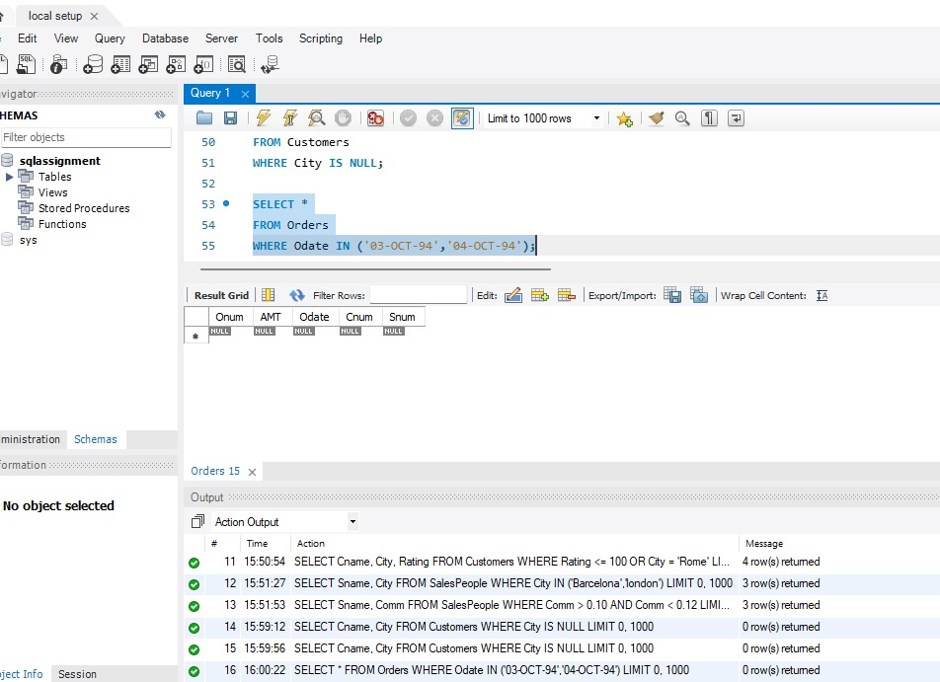

Fig. 1 shows the programming code and output

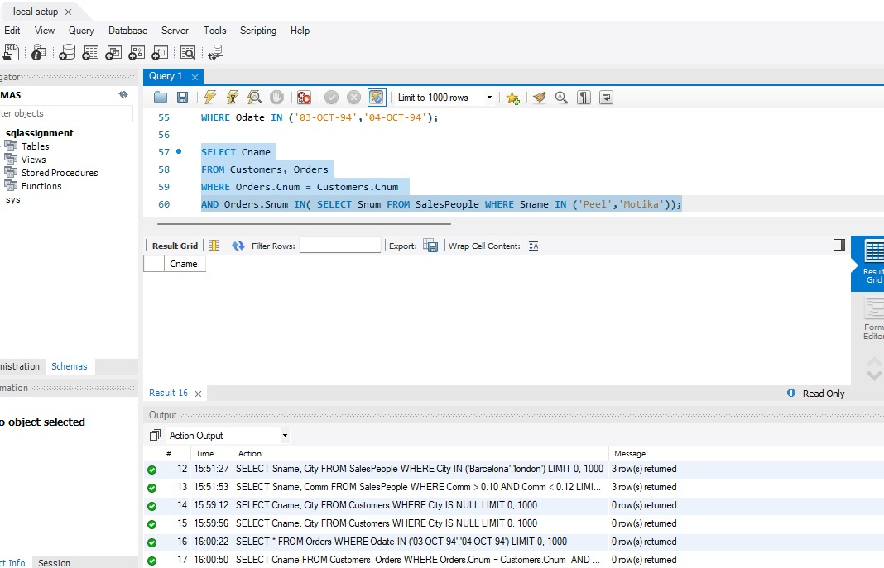

Fig 2 shows the programming code and output

**What is Front-End Development?**

Front-end development primarily focuses on user experience. Using the related coding and design techniques, you as front-end developers build the elements of an application that are directly accessed by end-users with a goal of rendering the entire interface elegant, easy to use, fast, and secure, fostering user engagement and interaction.

Thanks to the latest design and technology trends geared for the front end, you can build increasingly more sophisticated designs and interaction patterns. Simultaneously, however, more complexity results, so much so that front-end development has become a specialized field that requires deep expertise.

The major trend in front-end development in recent years is the growth of applications for mobile and smart devices, with users accessing applications from a growing number of devices with different screen sizes and interaction options. As a result, front-end developers must ensure their application delivers a consistent, high-quality user experience for all devices and usage scenarios. That’s a daunting challenge.

**Programming language for the Front End**

Below are the most common programming languages for developing the front end.

#### **HTML**

The HyperText Markup Language (HTML) programming language, which defines the structure and meaning of web content, is a building block for front-end development. Through HTML, browsers display text or load elements, rendering webpages, which contain hyperlinks and links to other webpages, for users.

#### **CSS**

Cascading style sheets (CSS) is the standard language that specifies how to display HTML content: fonts, foreground and background colors, etc. With CSS, you can control the design layout and its components for various devices like desktops, tablets, and smartphones. Examples of the components are the header, body, footer, content, asides, and sections.

#### **JavaScript**

JavaScript (JS) extends the functionality of websites beyond HTML and CSS. Through JS:

* Webpages can refresh themselves dynamically and respond to user actions without page reloads or other changes.
* You can model animated UI components, such as pop-ups, image sliders, and extensive navigation menus.

**Front-End Development Frameworks**

Front-end frameworks accord you ready-made code and components, such as prewritten standard functions packaged as libraries, with no need to build common functionality and components from scratch.

#### **Angular**

With Angular, a popular, open-source JavaScript framework initially created by Google, you can deliver highly dynamic results through the HTML syntax. Angular adopts an efficient modular approach and follows the MVC architecture, which divides the website structure into three parts: model, view, and controller (MVC). In particular, Angular facilitates cleaner code through TypeScript and leverages the dependency-injection design pattern.

#### **React**

Introduced in 2011 by Meta and now supported by a large community, React is an open-source, declarative JavaScript framework whose component-based approach enables code reuse. React facilitates more efficient updates of views with the virtual Document Object Model (VDOM), a lightweight JavaScript representation of the DOM, enhancing performance. You can use React to develop single-page applications (SPAs).

#### **jQuery**

Widely used and supported by many user-created plugins, jQuery is an open-source JavaScript library that simplifies the development of web applications. For example, jQuery edits CSS properties by incorporating JavaScript functionalities and applies effects, such as fade-in and fade-out, to website elements. With jQuery, you can also simplify the processes of implementing HTML DOM changes, event handling, and Asynchronous JavaScript and XML (Ajax).

#### **Vue.Js**

Written in JavaScript, Vue.js is a core library that focuses on the view layer only, enabling the development of distinct web interfaces and single-page applications. You can integrate this library with other tools and libraries for the desired output.

#### **Bootstrap**

A popular, open-source framework for developing responsive and mobile-first websites, Bootstrap offers CSS-based and JavaScript-based templates that include components like navigation bars, progress bars, thumbnails, and dropdowns, all of which you can incorporate into webpages.

Bootstrap implements responsive images through built-in code that automatically resizes them according to the current screen size. Also, with the JQuery plugins in Bootstrap, you can build and deliver interactive solutions for modal popups, image carousels, and transitions.

#### **Semantic UI**

A well-documented development framework for creating responsive layouts with HTML, Semantic UI relies on the semantic language to facilitate development and offers components for various features. You can integrate Semantic UI with many third-party applications and tools.

#### **Svelte**

Svelte is a compiler that converts declarative components into highly optimized vanilla JavaScript that surgically updates the DOM during the build phase of the development process. That’s a different approach from that in frameworks like Vue and React, which work in users’ browsers while the applications are running.

#### **Preact**

Preact offers a thin VDOM abstraction, registers real event handlers, builds on stable platform features, and integrates with other libraries. You can use Preact directly in browsers without transpilations. Preact is so light that developer code is the largest part of the application. As a result, there’s less JavaScript to download, parse, and execute, freeing you up for other tasks.

#### **Ember.js**

Ember.js is an open-source JavaScript framework for developing large client-side web applications with structured and organized code according to the MVC model. This framework uses route as a model and a handlebar template for views, as well as employs controllers to edit the data in the model.

**Responsive Web Development**

Here’s a frequently asked question: “**What Is responsive web development?**” RWD, also known as responsive design, is a web-design approach that emphasizes user experience. The objective is to ensure consistent rendering of webpages on various devices, screens and windows of different shapes and sizes, etc. Such an approach has become important given the rise of mobile devices, with most web traffic coming from mobile-device users. Real-world implementations of RWD abound, which most users, who focus on only the convenience and appeal of websites, rarely notice.

Following are several techniques with which to make websites responsive to various conditions:

* **Flexible grids.** Grids are a standard design tool for building websites. Responsive websites require a flexible grid that can load in different ways, depending on the screen or window size.
* **Breakpoints.** Similar to flexible grids, breakpoints are dots on a page that identify cut-off points so that information can move on the screen. Most websites have numerous breakpoints, but a minimum should be three to correspond to the three most common device types.
* **Prioritization.** Effective designs usually place the most important images and information higher up on the webpage, ensuring that visitors see them first. This visual hierarchy is especially crucial for responsive websites because smaller screens display less of a page at a given time. Prioritizing the important elements keeps mobile-device users engaged.
* **Flexible images.** Images are often harder to fit into different screen sizes than plain text. Web designers use various techniques to ensure that web pages display images appropriately on different screens. For example, the display might crop parts of an image for a better fit. In the case of multiple image versions for a site, select the version to render based on the device type or screen size.
* **Responsive media queries.**These are coding commands that set the maximum and minimum dimensions for media assets and that specify their orientation. As a result, all media assets on a webpage load at the appropriate size.
* **Mouse and touchscreen-friendly elements.** Desktop users are adept with their mouse device, but some actions are less intuitive on mobile devices. Responsive websites must accommodate smartphones by ensuring that every action is easily accessible through a touchscreen. Links must be large and obvious on small screens, and scrolling must be easy across device types. Be sure to test the user experience to ensure that all the elements work well on different devices.

**Types of Web Applications**

Web applications are divided into six types.

#### **Static Web Applications**

Based on HTML and CSS, static web applications contain no dynamic elements and are primarily for displaying content and data only, allowing no interactions between users and servers. Hence, these applications, the common ones being portfolio sites and official company sites, are relatively easy and simple to build, modify, and manage. Note that despite being static, these applications can include videos, GIFs, and animated banners.

#### **Dynamic Web Applications**

Dynamic web applications offer interactions between the server and user, i.e., the user makes a request, which the server accepts and then generates content in real time. These applications, which often hold databases or forums and which constantly update or modify the content, usually perform updates through a content management system (CMS). You can build these applications with various web languages, but PHP and ASP are the best for structuring content.

#### **E-Commerce Web Applications**

E-commerce web applications, which are online stores that promote and sell products or services, typically offer a rich set of features that facilitate purchase transactions. As a rule, these are interactive applications through which users can interact with the server and which you can integrate with other systems to better manage interactions and inventory.

#### **Single-Page Applications**

Single-page applications (SPAs) display updated content by loading a single document with a JavaScript API, e.g., XMLHttpRequest and Fetch. Consequently, since users need not load new webpages from the server, higher performance and a dynamic user experience follow. However, because SPAs are more complex than other web applications, more effort is required to monitor the performance, maintain the state, and implement navigation capabilities.

#### **Progressive Web Applications**

Progressive web applications (PWAs), which are websites that function as mobile applications through mobile-native features, require no software purchases or downloads from app stores by users. To locate and access PWAs on their browser, users can start with a search-engine query.

With PWAs, you can develop mobile-native applications for mobile operating systems. As with YouTube videos, devices progressively download PWA content, delivering a more smooth user experience than that from traditional websites through responsive design.

Ultimately, PWAs offer mobile browsers many benefits of native applications with a goal of blurring the distinction between mobile-web and mobile-native applications.

#### **SaaS Applications**

Given that the software-as-a-Service (SaaS) delivery model enables hosting of applications, independent software vendors (ISVs) can contract with a cloud provider for that service. Cloud providers can also serve as ISVs.

SaaS applications typically adopt a multitenant approach, running a single application instance on host servers. That instance serves each cloud tenant or customer while the application runs on a single version and configuration slated for all tenants or customers. Thus, multiple customers run on the same cloud instance through a common infrastructure and platform even though their data remains segregated.

As a result of that setup, cloud providers can apply changes for all customers through a single, shared instance, more efficiently performing maintenance tasks, fixing bugs, and delivering updates.

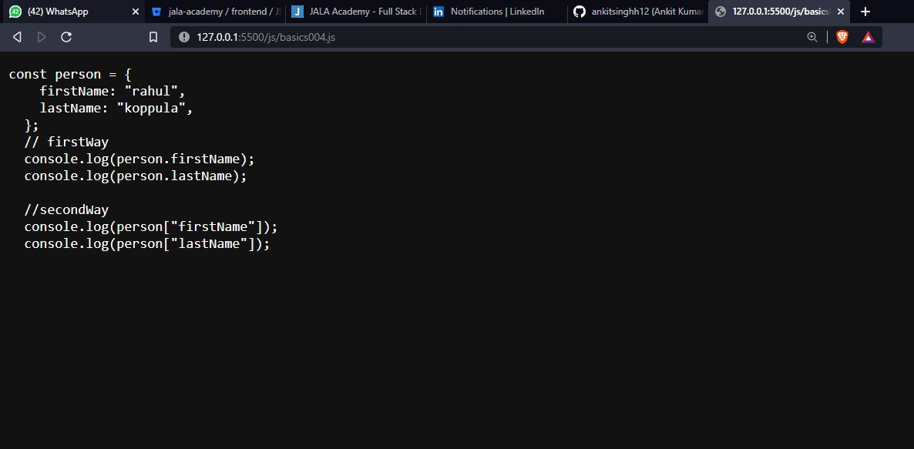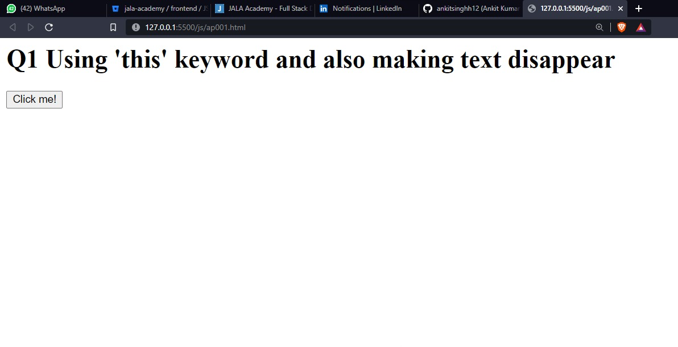

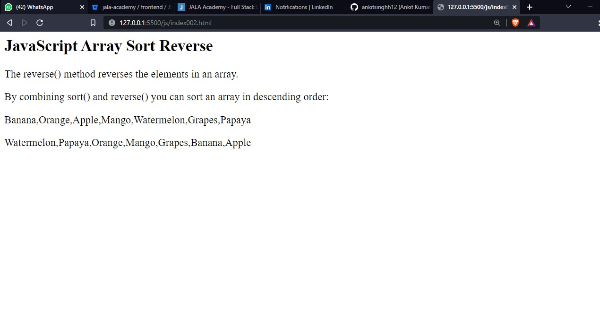

**CONCLUSION**

Java has been an essential language and right now it stands in 2nd place after python which means most of the companies still now test java skilled employees in their companies to make sure they have enough knowledge in coding and can handle them , moving on to the other two elements It’s important that SQL is mainly used in the sorting and making data tables and gather info together and sort them according to your wish and help us easily find new ways in solving problems, frontend development has been in here since the 90’s and it like mandatory to know about the 3 of them which help us build a web page

**BIBILIOGRAPHY**

* https://leverageedu.com/
* https://cloudinary.com/